**Project Design Phase-II**

**Technology Stack(Architecture and Stack)**

|  |  |
| --- | --- |
| Date | 21.10.2022 |
| Team ID | PNT2022TMID23566 |
| Project Name | IoT based smart crop Protection System for Agriculture |
| Maximum marks | 4 marks |

**TECHNICAL ARCHITECTURE :**



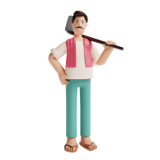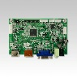

**CONTROL CENTRE :**

**CLOUD SERVICES :**

**CROP PROTECTION :**

**Anemometer**

**Solar panel**

**TOF sensor**

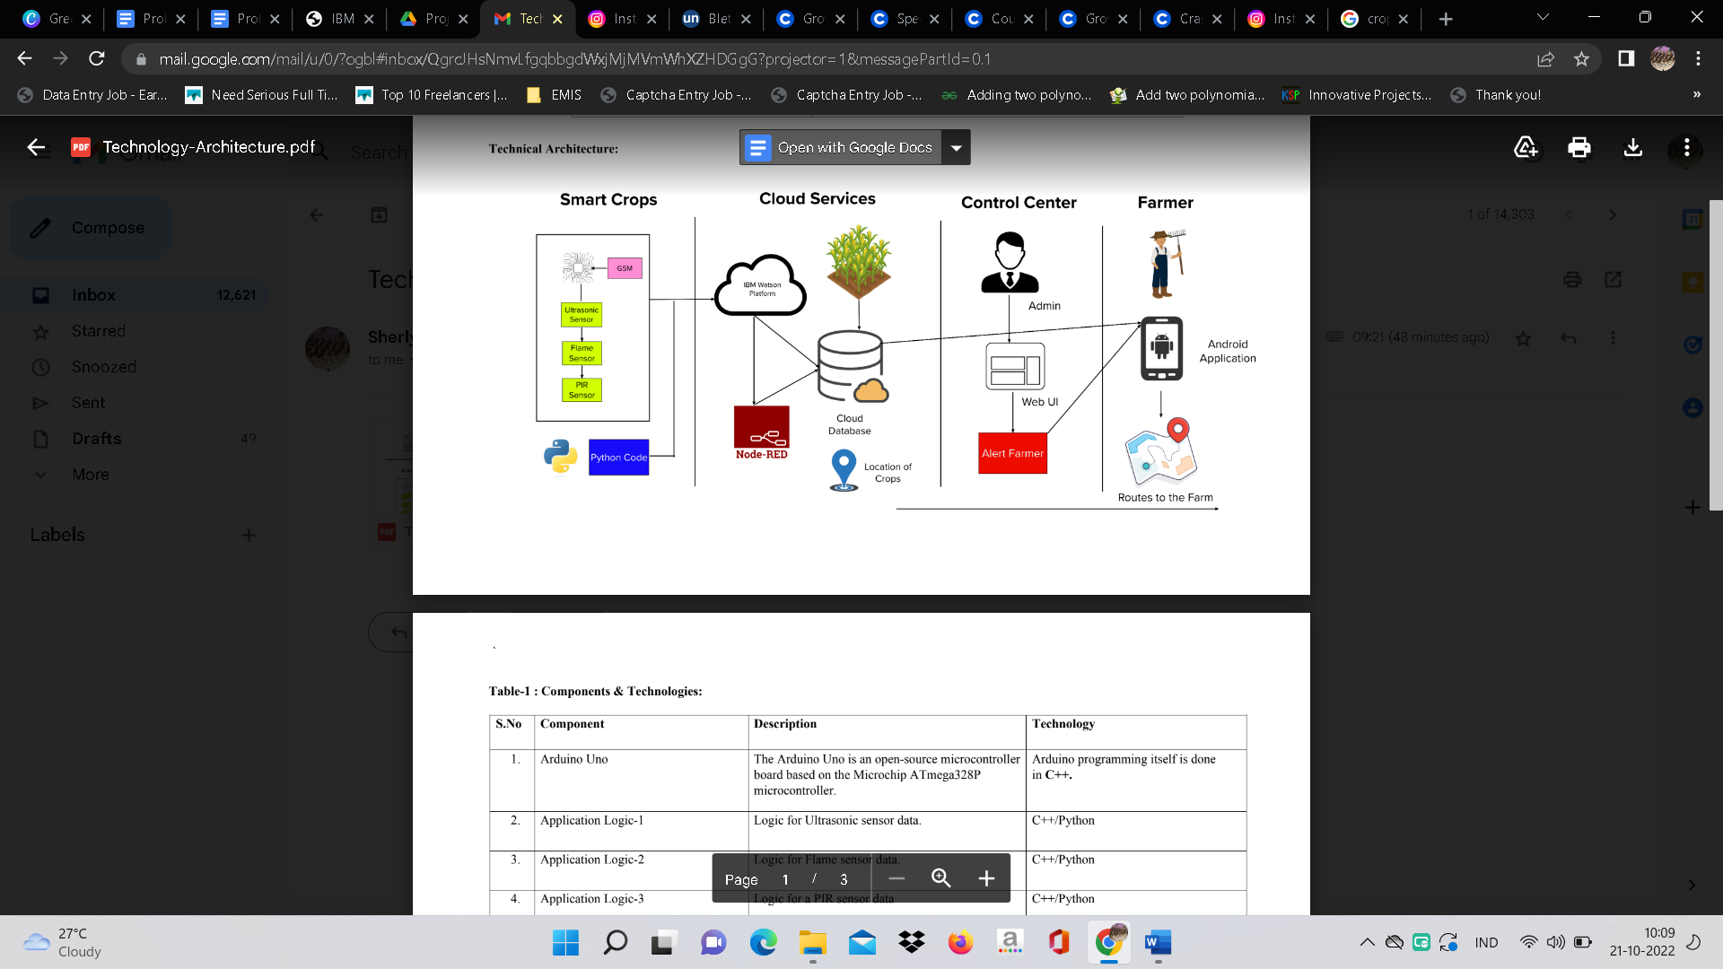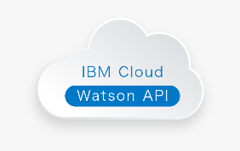

**FARMERS**



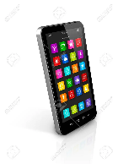



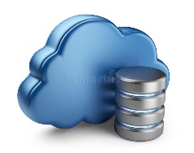

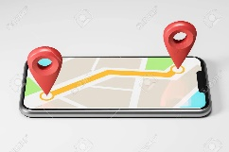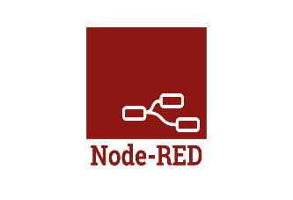



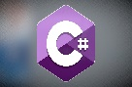

|  |  |  |  |
| --- | --- | --- | --- |
| **S.No** | **Component** | **Description** | **Technology** |
| 1. | Controller Board | LCD controller boards (A/D boards) designed to support LCD panels used in monitors and displays for commercial, industrial, harsh environment and specialist applications. | C# / Python |
| 2. | Application logic-1 | Logic for TOF sensor data | C# / Python |
| 3. | Application logic-2 | Logic for anemometer data | C# / Python |
| 4. | GSM | The GSM Module is directly connected to the microcontroller as the logic levels of both the GSM Modem and Microcontroller are already matched in the GSM Module Board. If there is no level converter on the board, then we need to use MAX232 level converter as a mediator between Controller and GSM to transfer the data. | C# / Python |
| 5. | Cloud server | Application deployment on Local System / Cloud | IBM Watson Iot platform, Node Red |
| 6. | Cloud Database | Database Service on Cloud | IBM Watson IoT Platform, Cloud DB |
| 7. | User interface | How user interacts with application to alert the farmer | Frontend/backend development |
| 8. | External API | Purpose of External API used in the application to locate the crops. | Google maps for geolocation |

**TABLE-1:COMPONENTS AND TECHNOLOGIES :**



**TABLE-2:APPLICATIONS CHARACTERISTICS :**

|  |  |  |  |
| --- | --- | --- | --- |
| **S.No** | **CHARACTERISTICS** | **DESCRIPTION** | **TECHNOLOGY** |
| 1. | Open source microcontroller | Controller board is used to make the IoT device | C#/Python |
| 2. | Security | Encryption/Decryption used for security purpose | GSM,Python |
| 3. | Scalabe architecture | New features can be added. | Node Red |
| 4. | Availability | Web application can be accessed from anywhere | IBM Watson IoT Platform, HTML, CSS,JavaScript |
| 5. | Performance | All farmers can access the application at same time | Cloud DB, IBM Watson IoT Platform |

